Oracle SOA Scheduler Implementation using EDN

EDN:

The Event Delivery Network (EDN) in Oracle SOA Suite 11g provides a declarative way to use a publish/subscribe model to generate and consume business events without worrying about the underlying message infrastructure.
Event Delivery Network allows publish-subscribe type of loose coupling by using Business events between SCA components.
This is similar to JMS/AQ model except that user is spared from remembering and using low level JMS connectivity details. Instead, SOA framework neatly abstracts these details in the Even Delivery Network so that users can purely focus on publishing and subscribing to events.
EDN is implemented through Business events.
So how can you make use of events?
a) First - you need to define the structure of the event. Event structure can be created in the form of an XSD.

b) Next we are defining the Business Event through EDL file (similar to a WSDL – Event Definition Language).
An event will be in its own namespace and imports the data shape through conventional means of a wsdl-alike import construct.

Scheduler Adapter:

Oracle SOA 11g doesn’t have any Scheduler JCA adapter and as such scheduling of a business process periodically will be an issue.

We can replicate the scheduling of bpel process using business events. Business events will be published to EDN layer from database, and we can “ FILTER “ the events in SOA layer.

Following is a demo for configuring the business events for a BPEL process.

- Create SOA application with an empty business Process.

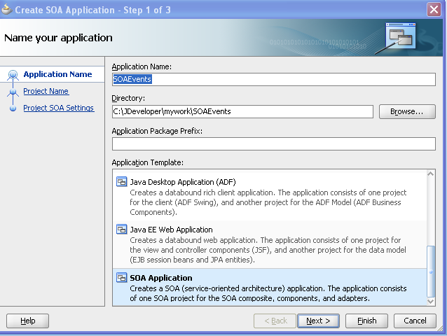

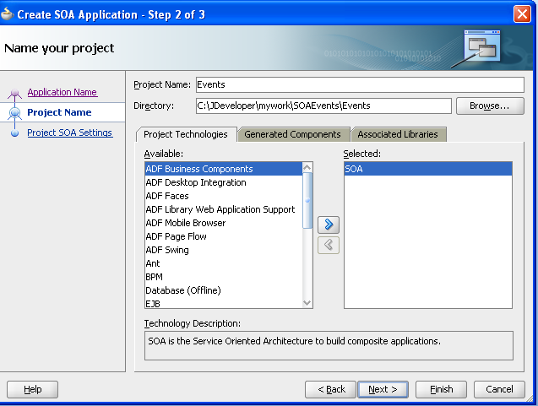

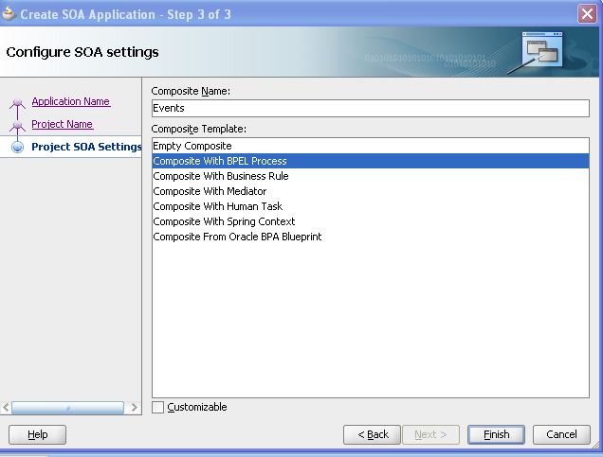

- Name the bpel process and select the “ Template “ as “ Subscribe to Events “.

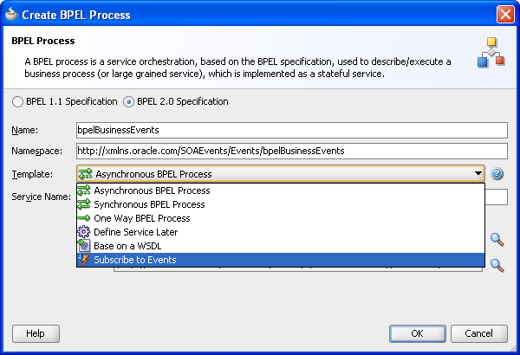

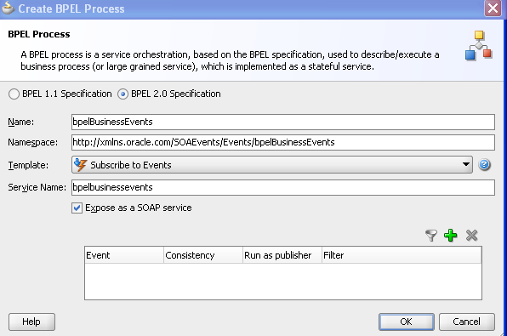

- Now create a new XSD, which will be used for the structure of the event.

EventDefinition.xsd
__________________________________________________________

<?xml version= '1.0' encoding= 'UTF-8' ?>
<xsd:schema xmlns:xsd="http://www.w3.org/2001/XMLSchema" xmlns="http://schemas.oracle.com/service/event"
targetNamespace="http://schemas.oracle.com/service/event" elementFormDefault="qualified">
<xsd:element name="Process" type="xsd:string"/>
</xsd:schema>

_______________________________________________________

- Now create a new Event Definition and an Event.

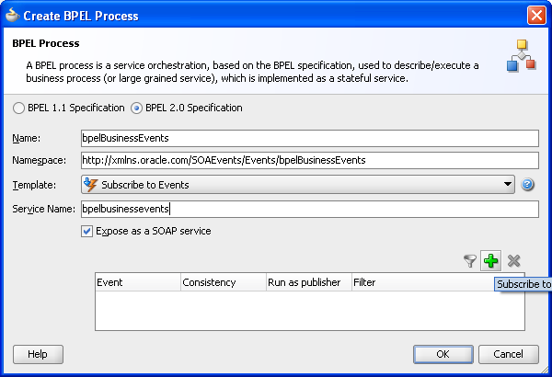

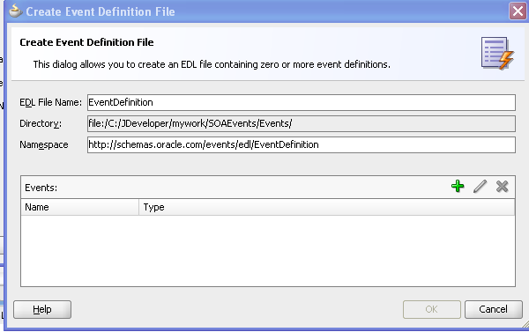

- Add an event to the Event Definition.

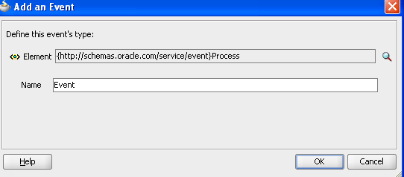

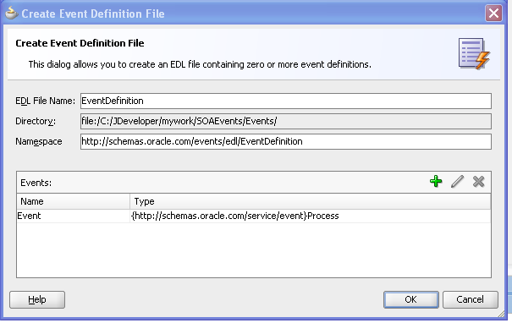

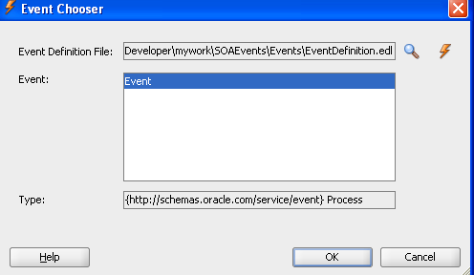

- Now we have created an EDL file and Event structure. But now we need to filter the events so as to use only for this bpel instance.

The filter should be “ Event Process Name = ‘bpelBusinessEvents’ “. This means that the bpel gets triggered only if the process name in the event is populated as “ bpelBusinessEvents “.

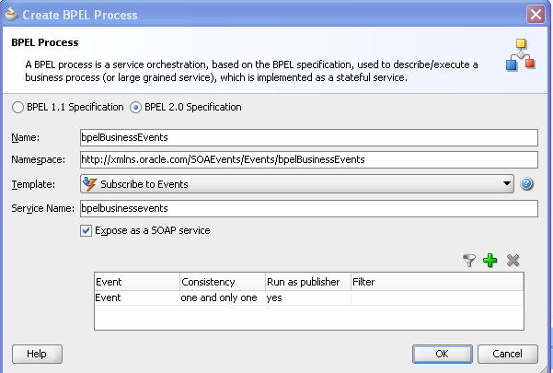

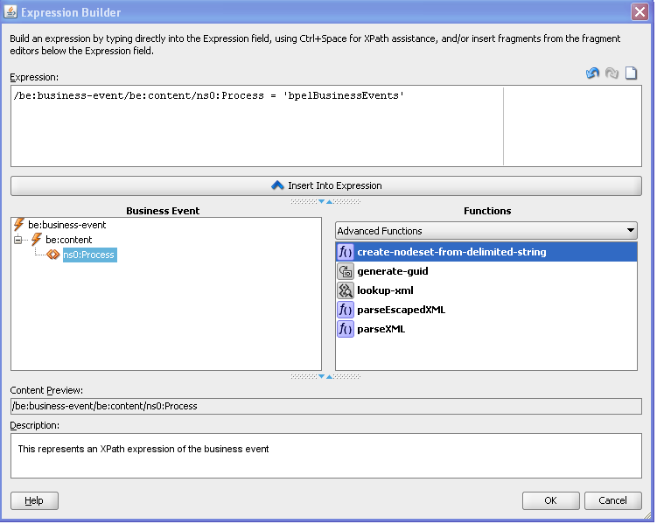

7) Now the BPEL process finally looks as below:

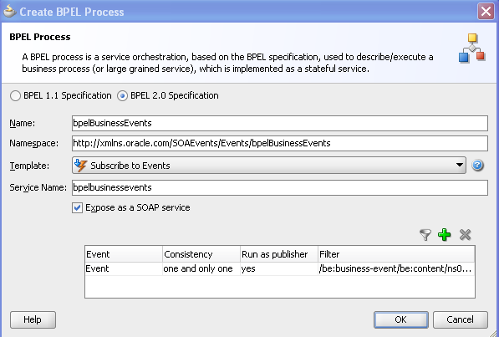

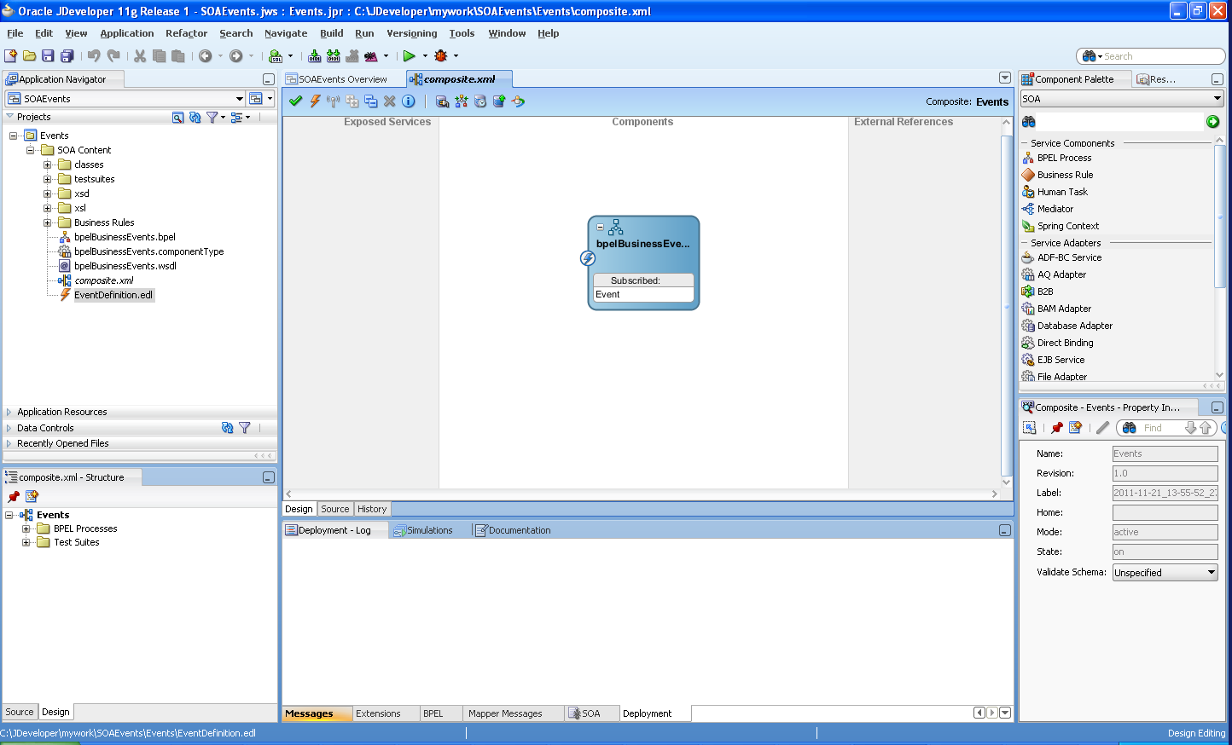

The source code for the EDL file is as follows:

_________________________________________________________________

<?xml version="1.0" encoding="UTF-8" standalone="yes"?>
<definitions xmlns="http://schemas.oracle.com/events/edl" targetNamespace="http://schemas.oracle.com/events/edl/EventDefinition">
<schema-import namespace="http://schemas.oracle.com/service/event" location="xsd/EventDefinition.xsd"/>
<event-definition name="Event">
<content xmlns:ns0="http://schemas.oracle.com/service/event" element="ns0:Process"/>
</event-definition>
</definitions>

Now create a stored procedure, which will publish the business events to the EDN layer from the DB layer.

The stored procedure is created in DEV_SOAINFRA database schema.

Final Stored Procedure:

CREATE PROCEDURE JDW_SCHEDULER
IS
seq NUMBER;
processName VARCHAR2(400);
lastUpdTime TIMESTAMP;
nextUpdTime TIMESTAMP;
intTime NUMBER;
currentTime TIMESTAMP;
CURSOR JDW IS SELECT SEQUENCE,PROCESSNAME,LASTUPDATEDTIMESTAMP,NEXTTRIGGERTIMESTAMP,INTERVAL FROM EDN_TRIGGER WHERE SCHEDULE='Y';
BEGIN
SELECT localtimestamp(6) into currentTime from dual;
OPEN JDW;
LOOP
FETCH JDW INTO seq,processName,lastUpdTime,nextUpdTime,intTime;
EXIT WHEN JDW%NOTFOUND;

IF(currentTime >= nextUpdTime) THEN
edn_publish_event(
'http://schemas.oracle.com/events/edl/EventDefinition',
'Event',
'<business-event xmlns:ns1="http://schemas.oracle.com/events/edl/EventDefinition" xmlns="http://oracle.com/fabric/businessEvent">
<name>ns1:Event</name>
<id>'||sys_guid()||'</id>
<content>
<Process xmlns:xsi="http://www.w3.org/2001/XMLSchema-instance" xsi:schemaLocation="http://schemas.oracle.com/service/event xsd/EventDefinition.xsd" xmlns="http://schemas.oracle.com/service/event">'||processName||'</Process>
</content>
</business-event>', '1');
UPDATE EDN_TRIGGER
SET NEXTTRIGGERTIMESTAMP= currentTime + numtodsinterval(intTime, 'SECOND')

WHERE SEQUENCE=seq;
COMMIT;
END IF;

END LOOP;
CLOSE JDW;
END;

____________________________________________________________________________

The stored procedure ideally will run as a cron job will look for process information in EDN_TRIGGER table and sends business events accordingly.

sql> EXECUTE JDW_SCHEDULER;

The Event Definition structure (XSD) and file (EDL file) can be stored in MDS and all other BPEL/Mediator processes will refer to these files within MDS store.

In order to replicate the scheduling mechanism, we need to come up with a DB table and populate all the process information in this table. The above stored procedure needs modification to get the process information from the table and publish the business events to the EDN layer.

The DB table structure can be as follows:

SEQUENCE NUMBER
PROCESSNAME VARCHAR2 (400)
LASTUPDATEDTIMESTAMP TIMESTAMP (6)
NEXTTRIGGERTIMESTAMP TIMESTAMP (6)
INTERVAL NUMBER
SCHEDULE CHAR(1)

Sample data:

SEQUENCE PROCESSNAME LASTUPDATEDTIMESTAMP NEXTTRIGGERTIMESTAMP
1 bpelBusinessEvents 21-NOV-11 01.33.51.140000 PM 21-NOV-11 01.33.51.140000 PM

INTERVAL SCHEDULE
- Y

